Indice

Beholder Pseudonatural 2

Cildabrin pseudonatural 3

Cloaker Lord Pseudonatural 4

Epic Overseer Pseudonatural 5

Epic Thoon Elder Brain Pseudonatural 6

Monolito Elementale Pseudonaturale 8

Moon-beast Pseudonatural 11

Zeugalak Pseudonatural 12

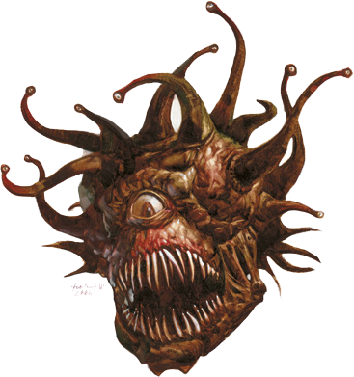Beholder  
Pseudonatural

**Large Aberration**

**Hit Dice:** 11d8+64 (120 hp)

**Initiative:** +6

**Speed:** 5 ft. (1 square), fly 20 ft. (good)

**Armor Class:** 46 (-1 size, +2 Dex, +15 natural, +20 insight), touch 31, flat-footed 44

**Base Attack/Grapple:** +8/+12

**Attack:** Eye rays +29 ranged touch and bite +22 melee (2d4)[5]

**Full Attack:** Eye rays +29 ranged touch and bite +22 melee (2d4)[5]

**Space/Reach:** 10 ft./5 ft.

**Special Attacks:** Eye rays, True strike

**Special Qualities:** All-around vision, Antimagic cone, darkvision 60 ft., flight, Epic summoning, DR 10/magic, Alternative form, Spell resistance 25, acid resistance 15, electricity resistance 15

**Saves:** Fort +29, Ref +25, Will +31

**Abilities:** Str 14, Dex 14, Con 22, Int 17, Wis 15, Cha 15

**Skills:** Hide +9, Knowledge (arcana) +12, Listen +13, Search +13, Spot +14, Survival +1 (+4 following tracks)

**Feats:** Alertness, Flyby Attack, Great Fortitude, Improved Initiative, Iron Will

**Environment:** Cold hills

**Challenge Rating:** 13

**Alignment:** Usually lawful evil

*It floats before you, a bulbous body with a central, unblinking eye, and a large maw filled with daggerlike teeth. Smaller eyes, attached to wriggling stalks, sprout from the top of the orblike body.*

Beholders are the stuff of nightmares. These creatures, also called the "spheres of many eyes" or "eye tyrants", are deadly adversaries.

Beholders speak their own language and Common.

Combat

The primary weapon of the beholder is a series of deadly eye rays. Beholders often attack without provocation. Though not powerful physically, they often plow right into groups of opponents to use as many of their eyes as they can. When closing with an enemy, a beholder tries to cause as much disruption and confusion as possible.

**Eye Rays (Su):** Each of a beholder's small eyes can produce a magical ray once per round as a free action. During a single round, the beholder can only aim three eye rays at targets in any one 90-degree arc (up, forward, backward, left, right, or down.) The remaining eyes must aim at targets in other arcs, or not at all. A beholder can tilt and pan its body each round to change which rays it can bring to bear in any given arc.

Each ray's effect resembles a spell (caster level 13) but is a straight line.

Each of a beholder's ten eye rays resembles a spell cast by a 13th-level caster. Each eye ray has a range of 150 feet and a save DC of 37. The save DCs are Charisma-based. The ten eye rays include:

*Charm Monster:* The target must succeed on a Will save or be affected as though by the spell. Beholders use this ray to confuse the opposition, usually employing it early in a fight. The beholder generally instructs a charmed target to either restrain a comrade or stand aside.

*Charm Person:* The target must succeed on a Will save or be affected as though by the spell. Beholders use this ray in the same manner as the charm monster ray.

*Disintegrate:* The target must succeed on a Fortitude save or be affected as though by the spell. The beholder likes to use this ray on any foe it considers a real threat.

*Fear:* This works like the spell, except that it targets one creature. The target must succeed on a Will save or be affected as though by the spell. Beholders like to use this ray against warriors and other powerful creatures early in a fight, to break up the opposition.

*Finger of Death:* The target must succeed on a Fortitude save or be slain as though by the spell. The target takes 3d6+13 points of damage if its saving throw succeeds. Beholders use this ray to eliminate dangerous foes quickly.

*Flesh to Stone:* The target must succeed on a Fortitude save or be affected as through by the spell. Beholders like to aim this ray at enemy spellcasters. They also use it on any creature whose appearance they find interesting. (After the fight, the beholder takes the statue to its lair as a decoration.)

Inflict Moderate Wounds: This works like the spell, causing 2d8+10 points of damage (Will half).

*Sleep:* This works like the spell, except that it affects one creature with any number of Hit Dice (Will negates). Beholders like to use this ray against warriors and other physically powerful creatures. They know their foes can quickly awaken the sleepers, but they also know that doing so takes time and can delay an effective counterattack.

*Slow:* This works like the spell, except that it affects one creature. The target can make a Will save to negate the effect. Beholders often use this ray against the same creature targeted by their disintegrate, flesh to stone, or finger of death ray. If one of the former rays fails to eliminate the foe, this ray might at least hamper it.

*Telekinesis:* A beholder can move objects or creatures that weigh up to 325 pounds, as though with a telekinesis spell. Creatures can resist the effect with a successful Will save.

**Antimagic Cone (Su):** A beholder's central eye continually produces a 150-foot cone of antimagic. This functions just like antimagic field (caster level 13th). All magical and supernatural powers and effects within the cone are suppressed - even the beholder's own eye rays. Once each round, during its turn, the beholder decides whether the cone is active or not (the beholder deactivates the cone by shutting its central eye).

**All-Around Vision (Ex):** Beholders are exceptionally alert and circumspect. Their many eyes give them a +4 racial bonus on Spot and Search checks, and they can't be flanked.

**Flight (Ex):** A beholder's body is naturally buoyant. This buoyancy allows it to fly at a speed of 20 feet. This buoyancy also grants it a permanent feather fall effect (as the spell) with personal range.

**Epic summoning (Su):** The creature makes all its attacks with a +20 insight bonus to-hit and a 10 insight bonus to damage, gain a +20 insight bonus to all saving throw, a +20 bonus to all CD’s and a +20 insight bonus to CA.

**True strike (Su):** Once per day, a pseudonatural creature can gain a +20 insight bonus on a single attack roll. In addition, the creature suffers no miss chance against a target that has concealment or total concealment when making this attack.

**Alternative form (Su):** As a standard action, a pseudonatural creature can take the form of a grotesque, tentacled mass (or another appropriately gruesome form, as determined by the DM). Despite the alien appearance, its abilities remain unchanged. Other creatures receive a –1 morale penalty on their attack rolls against a pseudonatural creature when it is in this alternate form.

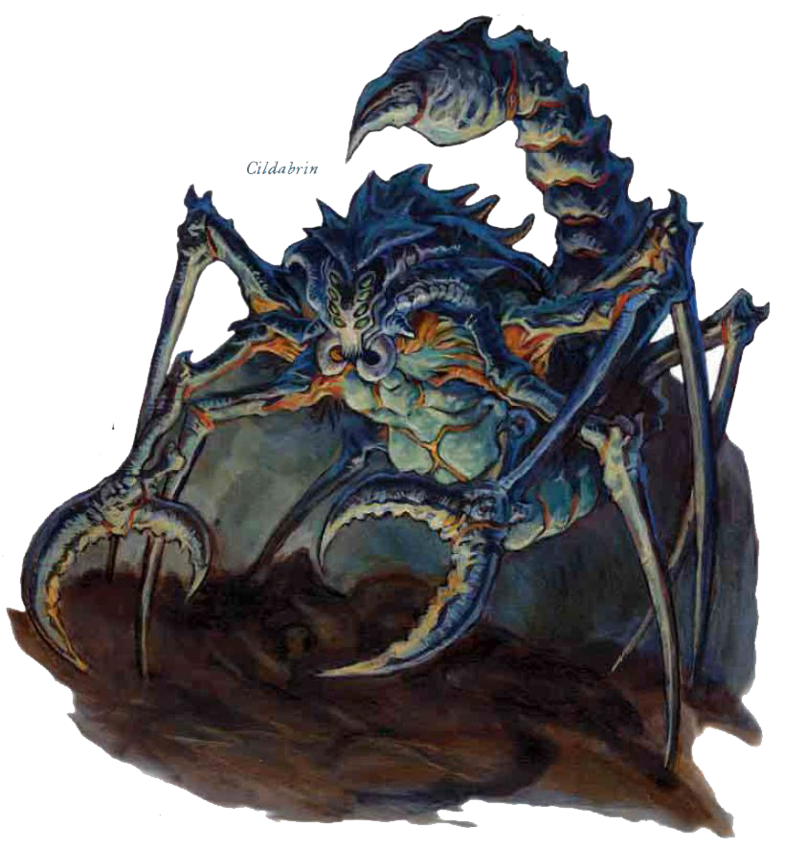Cildabrin  
pseudonatural

**Large Aberration (Extraplanar)**

**Hit Dice:** 20d8+160 (240 hp)

**Initiative:** +3

**Speed:** 50 ft. (10 squares), climb 20 ft.

**Armor Class:** 42 (–1 size, +3 Dex, +20 natural, +20 insight), touch 22, flat-footed 39

**Base Attack/Grapple:** +15/+32

**Attack:** Pincer +34 melee (1d6+17) [20]

**Full Attack:** 2 pincers +34 melee (1d6+17)[20], tail stinger +32 melee (1d8+15 plus poison)[20]

**Space/Reach:** 10 ft./10 ft.

**Special Attacks:** Constrict 1d6+10, improved grab, poison, spell-like abilities, True strike

**Special Qualities:** Darkvision 60 ft., tremorsense 60 ft., Epic summoning, DR 10/magic, Alternative form, Spell resistance 25, acid resistance 15, electricity resistance 15

**Saves:** Fort +28, Ref +26, Will +27

**Abilities:** Str 28, Dex 17, Con 26, Int 11, Wis 10, Cha 13

**Skills:** Climb +22, Jump +22, Move Silently +10, Spot +11

**Feats:** Dodge, Mobility, Multiattack, Spring Attack

**Environment:** Underground

**Organization:** Solitary

**Challenge Rating:** 18

**Alignment:** Usually neutral evil

*This spiderlike horror has long pincers in place of its forelegs, and a scorpion’s tail in place of the spider’s spinnerets. The body itself is chitinous and blue-black, but tufts of dark brown hair, like those of a tarantula, grow out of the joints. The creature’s eight turquoise eyes don’t seem to reflect any light.*

Cildabrins are subterranean hunters that prefer temperate or warm underground regions. Incapable of spinning normal webs, cildabrins roam their territory like great wolves, looking for any prey they can catch and tear to shreds with their powerful pincers. Once they catch their food, it is poisoned into submission or killed. The cildabrin then retreats to its lair—a warm, dark cave—to eat at its leisure. It devours its prey like a scorpion rather than a spider; its pincers tear off shreds of flesh small enough for the creature to chew with its mandibles. A cildabrin has no interest in any gear or valuables its prey carries, beyond the possibility that scattering such items around its territory might attract more prey.

Sages speculate that cildabrins might be a created race, not one that evolved naturally. Those who espouse this theory point to the aberration’s remarkable similarities to two other natural kinds of arachnid creatures: hunting spiders (such as tarantulas) and scorpions. Cildabrins seem incapable of true speech but can communicate with other arachnids. They are sentient; they merely lack the means to vocalize sounds.

When roaming underground, cildabrins sometimes stray perilously close to dungeons, sewers, crypts, and other subterranean elements of civilization. Despite legends to the contrary, it does not seem that cildabrins are tools of the drow. The dark elves fear these terrible beasts at least as much as other humanoids do. In fact, some religious sects among the drow consider the appearance of a cildabrin to be a dire omen. For their own part, these aberrations seem to prefer dwarf flesh above all else.

**Combat**

As a solitary hunter, a cildabrin prefers to stalk its prey. It slowly closes the distance to the quarry after using its spell-like silence ability, and then leaps to the attack. If hunting a lone figure or a small group, a cildabrin remains in melee, trying to kill or incapacitate as many targets as possible. If engaging a large or powerful group of prey, a cildabrin uses its Spring Attack feat to snatch up one or two targets, tries to trap any remaining foes in its spike stones, casts darkness to cover its escape, and then flees to kill and consume its prey later in safety. Its long claws and segmented, scorpionlike tail give it exceptional reach in combat.

**Constrict (Ex):** A cildabrin deals an extra 3d6+10 [20] points of damage with a successful grapple check.

**Improved Grab (Ex):** To use this ability, a cildabrin must successfully attack with a pincer. It can then attempt to start a grapple as a free action without provoking attacks of opportunity. If it wins the grapple check, the cildabrin establishes a hold and deals constrict damage. Cildabrins gain a +4 racial bonus on grapple checks. A cildabrin might choose to grapple with one pincer only (grapple bonus +3), especially against Small opponents or opponents that have been weakened by its poison. This tactic leaves the monster free to move or use its other attacks against different opponents.

**Poison (Ex):** Injury, Fortitude DC 40, initial and secondary damage 1d6 Str. The save DC is Constitution-based.

**Spell-Like Abilities:** 3/day—darkness, silence (DC 36), spike stones (DC 36). Caster level 18th. The save DCs are Charisma based.

**Skills:** Cildabrins have a +8 racial bonus on Climb checks and a +4 racial bonus on Spot checks. A cildabrin can always choose to take 10 on Climb checks, even if rushed or threatened.

**Epic summoning (Su):** The creature makes all its attacks with a +20 insight bonus to-hit and a 10 insight bonus to damage, gain a +20 insight bonus to all saving throw, a +20 bonus to all CD’s and a +20 insight bonus to CA.

**True strike (Su):** Once per day, a pseudonatural creature can gain a +20 insight bonus on a single attack roll. In addition, the creature suffers no miss chance against a target that has concealment or total concealment when making this attack.

**Alternative form (Su):** As a standard action, a pseudonatural creature can take the form of a grotesque, tentacled mass (or another appropriately gruesome form, as determined by the DM). Despite the alien appearance, its abilities remain unchanged. Other creatures receive a –1 morale penalty on their attack rolls against a pseudonatural creature when it is in this alternate form.

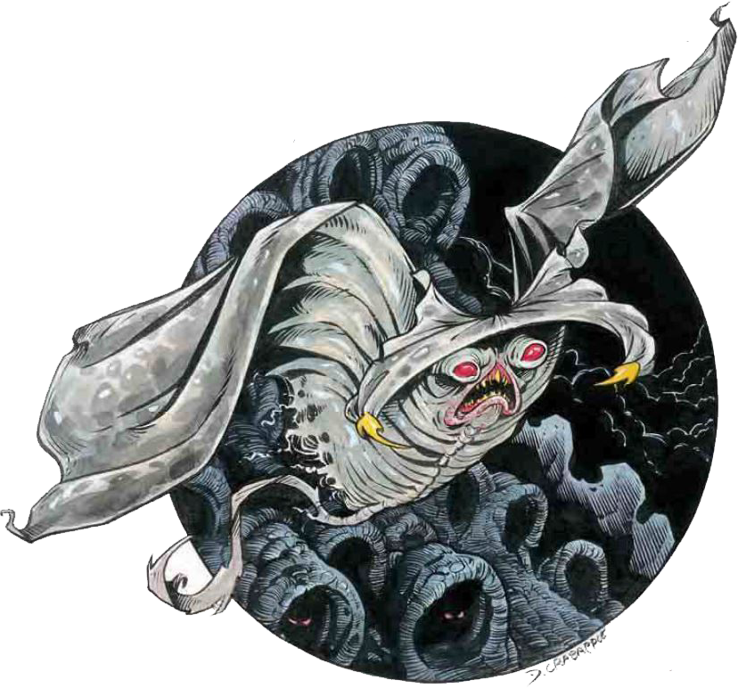Cloaker Lord  
 Pseudonatural

**Huge Aberration**

**Hit Dice:** 9d8+65 (110 hp)

**Initiative:** +5

**Speed:** 10 ft., fly 50 ft. (average)

**Armor Class:** 37 (-2 size, +1 Dex, +8 natural, +20 insight), touch 29, flat-footed 36

**Base Attack/Grapple:** +6/+42

**Attack:** Tail slap +32 melee, bite +27 melee

**Full Attack:** Tail slap +32 melee (2d6+18 [25]) and bite +27 melee (2d4+14 [20])

**Space/Reach:** 15 ft./10 ft. (5 ft. with bite)

**Special Attacks:** Moan, engulf spellcasting, dominate dual, True strike

**Special Qualities:** darkvision 60 ft., Shift, Plane shift, Shadow Blend, Epic summoning, DR 10/magic, Alternative form, Spell resistance 25, acid resistance 15, electricity resistance 15

**Saves:** Fort +28, Ref +26, Will +29

**Abilities:** Str 30, Dex 13, Con 24, Int 15, Wis 17, Cha 15

**Skills:** Hide +5, Knowledge (arcana) +16, Listen +15, Move Silently +13, Spellcraft +18, and Spot +15

**Feats:** Blind-fight; Combat Reflexes; Combat Expertise; Improved Initiative; Lightning Reflexes

**Climate/Terrain:** Underground

**Alignment:** Usually chaotic neutral

Combat

Cloaker lords initially use their moan attack to thin the numbers of their opponents. With some opponents fleeing, nauseated, or held, the cloaker lord chooses the most dangerous or powerful remaining opponent (usually a wizard) and tries to engulf that character, while fighting off other attackers with its thick-muscled, bone-barbed tail.

**Moan (Ex):** As a free action, a cloaker lord can emit a dangerous subsonic moan at will, as long as it does not use its bite attack in the same round. By varying the frequency and intensity of the moan, a cloaker lord can create one of four different effects:

*Unnerve:* All within 90 feet of the cloaker lord suffer a -2 morale penalty on attack and damage rolls. Those forced to hear this sound for 6 consecutive rounds must make a Will save (DC 36) or enter a trance and become unable to attack or defend themselves until the moaning stops. Opponents who successfully save must repeat the save next round if the moaning continues.

*Fear:* All those within 40 feet of the cloaker lord must make a Will save (DC 36) or flee in terror for 2 rounds.

*Nausea:* Everyone in a 40-foot cone must attempt a Fortitude save (DC 36) or be overcome by nausea and weakness. Affected characters fall to the ground and are unable to take any actions, including defending themselves, for 1d4+1 rounds.

*Stupor:* A single individual no more than 50 feet from the cloaker lord must make a Fortitude save (DC 36) or be affected as by a hold monster spell for 6 rounds. A cloaker lord can affect only one victim at a time with this ability, so if it decides to affect one character while another is still under the effect of the stupor, the previous effect is canceled.

**Engulf (Ex):** A cloaker lord can try to wrap a foe of large size or smaller in its body. The cloaker lord makes a grapple attack that does not provoke an attack of opportunity. If the cloaker lord achieves a hold, it is free to use its whip like tail to strike at other targets while it gnaws on an engulfed victim. The cloaker lord can bite the engulfed foe with a +4 attack bonus.

Attacks made on an engulfing cloaker lord deal half their damage to the monster and half to the trapped victim.

**Spellcasting:** Cloaker lords have the spellcasting ability of 17th-level wizards, and this ability improves as they increase in size and Hit Dice. They are considered specialists in spells of the shadow sub-school: *Typical Sorcerer Spells Known* (3/3/3/3/3/3/3/2/1) per day; caster level

17th, DC 32 + spell level):

1st - *chill touch, ray of enfeeblement, sleep*; 2nd - *blur, darkness, scare, spectral hand*; 3rd - *gaseous form, nondetection, phantom steed*; 4th - *enervation, Evard's black tentacles, feat minor creation, shadow conjuration*; 5th - *greater shadow conjuration, major creation, passwall, shadow evocation*; 6th - *greater shadow evocation, shades*; 7th - *phase door, shadow walk*; 8th - *etherealness, maze*; 9th - *energy drain*.

Cloaker lords cast all their spells with verbal components only.

**Dominate Cloakers (Ex):** Cloaker lords have a natural power of domination over ordinary cloakers, allowing them to rule as the unquestioned leaders in cloaker communities.

**Shadow Blend (Su):** In any conditions other than full daylight, a shadowcloak elder can disappear into the shadows, giving it total concealment. Artificial illumination, even a light or continual flame spell, does not negate this ability, but a daylight spell will.

**Shadow Shift (Su):** Cloaker lords have the ability to manipulate shadows. This power is effective only in shadowy areas and has several possible effects:

*Obscure Vision:* The cloaker gains one-quarter concealment for 1d4 rounds.

*Dancing Images:* This duplicates the effect of a mirror image spell cast by a 17th-level sorcerer.

*Silent Image:* This duplicates the effect of a silent image spell cast by a 17th-level sorcerer.

**Plane Shift (Sp):** Cloaker lords can travel to and from the Plane of Shadow at will. Once per day, they can bring up to seven cloakers along with them on such a journey, as the spell plane shift.

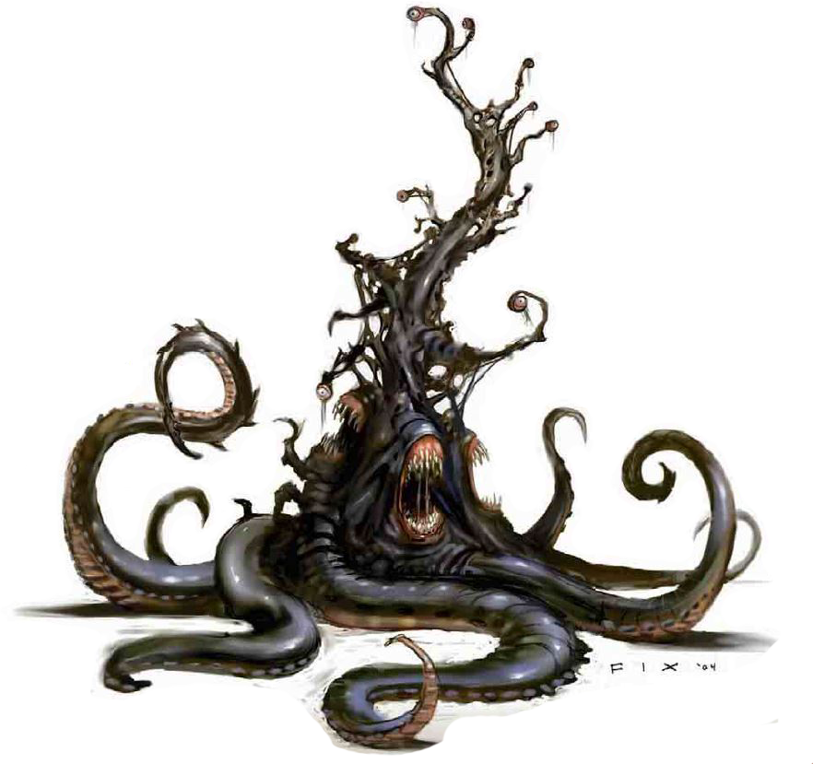Epic Overseer  
Pseudonatural

**Gargantuan Outsider**

**Hit Dice:** 40d8+600 (920 hp)

**Initiative:** +9

**Speed:** 60 ft. (12 square)

**Armor Class:** 43 (–3 size, +5 Dex, +6 fungus armor, +35 natural), touch 12, flat-footed 38

**Base Attack/Grapple:** +30/+67

**Attack:** Eye rays +30 ranged touch and tentacle rakes +40 melee (2d8+12 [20])

**Full Attack:** Eye rays +30 ranged touch and 18 tentacle rakes +40 melee (2d8+12 [20]) and 3 bites +40 melee (3d6+10 [20])

**Space/Reach:** 20 ft./20 ft.

**Special Attacks:** *Command beholder,* constrict 2d6+14 [20], eye rays, improved grab

**Special Qualities:** All-around vision, darkvision 60 ft., fungus, spell resistance 40, electricity and acid resistance 60, DR 30/+7

**Saves:** Fort +32, Ref +18, Will +35

**Abilities:** Str 60, Dex 21, Con 40, Int 20, Wis 28, Cha 22

**Skills:** Knowledge (any four) +22, Listen +21, Search +22, Spot +21, Survival +4 (+6 following tracks)

**Feats:** Alertness, Enlarge Spell, Great Fortitude, Improved Initiative, Metaray†, Maximize Spell, Epic fortitude, Enhance Spell, Epic speed, Epic Will.

† New feat described on page 45.

**Environment:** Cold hills

**Alignment**: Always lawful evil

**Challenge Rating:** 50

*This creature resembles a black, rubbery tree of undulant flesh. Thick, matted sheets of wiry fungus grow all over its surface. The tree’s thirteen gnarled branches each end in a single large eye. Three fanged maws gurgle lower on the tree’s trunk, and it supports itself with a thick, coiling mass of eight long tentacles.*

Overseers serve hive mothers as subordinates in large beholder communities, similar to the way humanoid rulers employ others as guards or governors. The rare overseer that does not belong to a beholder community seeks out societies of other creatures to infiltrate and dominate from behind the scenes. An overseer is uncomfortable without a large number of subservient minions to tend to its real (or imagined) needs. An overseer is normally about 15 feet tall and weighs 4,000 pounds. They speak Beholder and Common.

Combat

Unlike most other beholderkin, overseers have a large number of physical attacks that they can use in melee combat to great effect. Nevertheless, they prefer to let their minions handle such crude activities as melee combat and concentrate on using their eye rays against enemies. An overseer’s greatest weakness is its lack of mobility; when faced with a foe that uses greater mobility to stay out of range of its eye rays, an overseer typically retreats to plot revenge on its own terms. Most overseers keep at least one magic item that allows some form of teleportation handy for just such an event.

**Command Beholder (Sp):** An overseer can use *dominate monster* at will as a spell-like ability (caster level 14th), but onlyagainst beholders and beholderkin (except for hive mothersand other overseers). A beholder can resist this effect with aDC 36 Will saving throw. The save DC is Charisma-based. Thisis the equivalent of a 9th-level spell.The maximum number of beholders an overseer can commandat one time equals its Hit Dice plus its Charisma modifier.Thus, the average overseer can command up to 20 beholdersor beholderkin at a time.If an overseer loses control of a *dominated* beholder (as isthe case if a *dominated* beholder is in the antimagic cone ofanother beholder), the overseer can immediately sense the lossof control and knows the position and distance to the beholderat the time control was lost. If control does not return within a few rounds, the overseer seeks out the rogue beholder to investigate and possibly punish it.

**Constrict (Ex):** An overseer deals 2d6+6 points of damage with a successful grapple check.

**Rotting Constriction (Ex):** Once the creature has hold of an opponent, each successful grapple check it makes during subsequent rounds permanently drains 2d4 points of Constitution. At the same time, the creature regains 10 lost hit points.

**Eye Rays (Su):** Each of a director’s thirteen small eyes can produce a magical ray once per round as a free action (except for its major creation eye ray; see below). An overseer’s long branches allow it to aim up to five eye rays at targets in any given 90-degree arc. It typically attacks with only four rays in any round, leaving it with the option to use its reactive spell turning or reactive spell immunity eye ray as needed. Each ray has a range of 180 feet, a save DC of 36, and a caster level of 40th. The save DCs are Charsma-based. The thirteen eye rays include:

*Chain Lightning*: This works like the spell, except that if the eye ray misses the initial target, the effect is wasted. Only if the initial target is hit does the lightning arc to other targets.

*Crushing Despair*: This works like the spell, except that it affects only a single target (Will save negates).

*Dominate Person*: The target must succeed on a Will save or be affected as though by the spell.

*Greater Dispel Magic*: This works like the spell, except that an overseer cannot perform an area dispel. If it wishes, it can prepare an action to use this eye to perform a counterspell, but if it does so, it must successfully hit the spellcaster in question.

*Hold Monster*: This works like the spell (Will negates).

*Major Creation*: An overseer uses this eye ray to create miscellaneous gear and equipment for itself or its minions (as the spell) as it deems necessary. It has no offensive function. This eye ray requires a full-round action to use.

*Polar Ray*: The target takes 25d6 points of cold damage.

*Reactive Spell Immunity*: Once per round, this eye can be used to negate a single spell that affects the overseer as the spell is being cast. The overseer must successfully hit the creature that cast the spell in question; if successful, it is immune to that casting of that particular spell. If the spell affects multiple targets or an area, it affects any other targets or the area normally, but the overseer remains immune to its effect. An overseer cannot use this eye ray if it is considered flat-footed against the source of the spell.

*Reactive Spell Turning*: Once per round, this eye can be used to reflect a single-target spell that targets the overseer back to its source as an eye ray. The overseer must hit the source with the eye ray; otherwise, the reflected spell dissipates harmlessly. An overseer cannot use this eye ray if it is considered flat-footed against the source of the spell.

*Stunning*: The target must succeed on a Fortitude save or be stunned for 1d4 rounds.

*Suggestion*: The target must succeed on a Will save or be affected as though by the spell.

*Telekinesis*: An overseer can move objects or creatures that weigh up to 350 pounds, as though with a *telekinesis* spell. Creatures can resist the effect with a successful Will save.

*Temporal Stasis*: The target must succeed on a Fortitude save or be affected as though by the spell.

**Improved Grab (Ex):** To use this ability, an overseer must hit with its bite attack. It can then attempt to start a grapple as a free action without provoking attacks of opportunity. If it wins the grapple check, it establishes a hold and can constrict.

**Fungus (Ex):** An overseer’s protective layer of thick, wiry fungus provides a +6 armor bonus to its Armor Class. This fungus doesn’t impede or restrict the overseer’s movement in any way. The fungus reacts to the overseer’s moods, and changes color as the beholderkin’s emotions change.

**Constant Insight (Su):** The creature makes all its attacks with a +15 insight bonus. The creature is not affected by the miss chance that applies to attacks against a concealed target.

**Spell-Like Abilities:** At will—blur, dimension door, shield, unhallow. Caster level 20th.

**Alternate Form (Su):** At will, a pseudonatural creature can take the form of a grotesque, tentacled mass (or another appropriately gruesome form determined by the DM), but all its abilities remain unchanged despite the alien appearance. Changing shape is a standard action. Other creatures receive a –1 morale penalty on their attack rolls against pseudonatural creatures in this alternate form.

Epic Thoon Elder  
Brain Pseudonatural

**Huge aberration (Extraplanar)**

**Hit Dice:** 35d8+665 (945 hp)

**Initiative:** +5

**Speed:** 20 feet (4 squares), fly 40 ft. (perfect), swim 60 ft.

**Armor Class:** 41 (–2 size, +2 Dex, +41 natural), touch 10, flat-footed 37

**Base Attack/Grapple:** +26/+59

**Attack:** tentacle +66 (1d8+25 plus 2d6 acid)

**Full Attack:** 8 tentacles +66 melee (1d8+25 [30] plus 2d6 acid [5]) or 15 tentacles +66 melee (2d8+25 [35] plus 2d6 acid [5]) (in alternate form)

**Space/Reach:** 10 ft./10 ft.

**Special Attacks:** Acid burn, Confusion sphere, Overmind blast, Spell-like abilities, improvered grab

**Special Qualities:** Dual action, Senses darkvision 60 ft., telepathy 1-mile, fast healing 10, Spell Resistance 26, immune electricity, immune acid, immune fear, costant insight, DR 30/+7, Spell resistance 40

**Saves:** Fort +34, Ref +11, Will +19 (+ stat)

**Abilities:** Str 60, Dex 12, Con 48, Int 25, Wis 33, Cha 23

**Skills:** Bluff +21, Concentration +25, Diplomacy +25, Intimidate +23, Knowledge (arcana) +22, Knowledge (religion) +22, Knowledge (the planes) +22, Listen +6, Sense Motive +21, Spellcraft +24, Spot +6 (+207)

**Feats:** Ability Focus (confusion sphere), Combat Reflexes, Improved Initiative, Sense Quintessence, Weapon Focus (tentacle), Multiattack, Armor skin (x3)

**Languages:** Undercommon

**Challenge Rating:** 50

**Alignment:** Usually neutral evil

*Floating in the air is a purple, bulbous mass that looks like a giant brain with trailing tentacles. You sense its telepathic power as an oily wave washes across your consciousness.*

Combat

A Thoon elder brain is best used as a climactic encounter—the big, bad monster at the end of an adventure. By the time the PCs reach a Thoon elder brain, they should have fought their way past dozens of mind fl ayers and other creatures of Thoon.

A Thoon elder brain’s tactics depend on whether it believes one or more foes to be vulnerable to its powers of domination. If so, the elder brain uses each of its mental actions to order an opponent to turn on that foe’s allies. If this tactic fails twice, the Thoon elder brain abandons it.

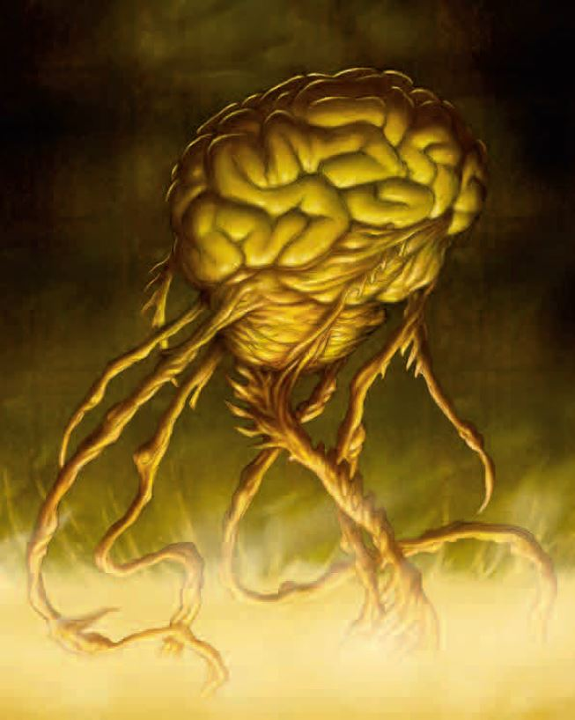Its tactics also depend on the number of opponents. If a Thoon elder brain is beset by multiple foes in melee, it uses its confusion sphere to disrupt its opponents’ tactics and its tentacles to damage anyone who isn’t confused. In situations when a Thoon elder brain has allies or is facing only a few adversaries, it uses its overmind blast from a safe distance. With its physical action, it readies a tentacle attack in case a foe moves within reach.

**Dual Action (Ex):** A Thoon elder brain is a creature made up of multiple minds, all touched by the unreality of the Far Realm. Make two initiative checks for the creature. The higher result represents a mental action turn, and the lower result is used for a physical action turn. This means a Thoon elder brain can do more in a single round than most creatures. For example, it could perform an overmind blast (a purely mental action) on initiative count 17, then move and make a tentacle attack (a physical action) on initiative count 12. These initiative counts can change if a Thoon elder brain readies an action or delays to let its other half go first.

**Acid Burn (Ex):** The acid delivered by a Thoon elder brain’s tentacles continues to burn in the round after the Thoon elder brain hits. At the beginning of each of a Thoon elder brain’s physical action turns, the acid deals 4d6 points of acid damage to any creature the Thoon elder brain hit with a tentacle attack during the previous round. The damage is always 4d6 points, regardless of how many times the Thoon elder brain hit the creature.

**Confusion Sphere (Su):** A Thoon elder brain can scramble the thoughts of nearby creatures. This ability functions like a confusion spell (CL 20th, Will DC 33 negate), except that all creatures (except for creatures of Thoon) within a 10- foot radius centered on the Thoon elder brain are subject to the effect. The effect lasts 15 rounds, but it cannot end for an affected creature when that creature is still within 10 feet of the Thoon elder brain. At the beginning of each affected creature’s turn, roll on the table below.

|  |  |
| --- | --- |
| d% | Effect |
| 01-10 | Attack the Thoon elder brain with melee or ranged weapons, or close with the elder brain if attack isn’t possible. |
| 11-20 | Act normally. |
| 21-50 | Do nothing but mutter “Thoon… Thoon…” |
| 51-70 | Flee from the Thoon elder brain at top speed. |
| 71-100 | Attack nearest creature. |

**Overmind Blast (Su):** A Thoon elder brain can project the horror of its consciousness against a single foe within 100 feet. That target must succeed on a DC 33 Will save or take 2d6 points of Wisdom damage. Though overmind blast isn’t a fear effect, a creature that has immunity to fear or a save bonus against fear receives a +4 bonus on the saving throw. The save DC is Charisma-based. A creature that is reduced to 0 Wisdom by an over mind blast is unconscious, but its body mutters, “Thoon… Thoon…” repeatedly until consciousness returns. A Thoon elder brain is an elder brain that has been twisted by its time in the Far Realm and now leads the mind flayers of Thoon.

**Spell-Like Abilities:** (CL 20th): At will—charm monster (DC 20), detect magic, detect thoughts (DC 18), mage armor, plane shift, suggestion (DC 19). Blur, dimension door, shield, unhallow 3/day – dominate monster (CD 25)

**Constant Insight (Su):** An Epic Toon Elder Pseudonatural makes all its attacks with a +15 insight bonus. The creature is not affected by the miss chance.

**Improved Grab (Ex):** If an Epic Toon Elder Pseudonatural hits an opponent smaller than it with a tentacle, it deals normal damage and attempts to start a grapple as a free action without provoking an attack of opportunity.

**Rotting Constriction (Ex):** Once an Epic Toon Elder Pseudonatural has hold of an opponent, each successful grapple check it makes during subsequent rounds permanently drains 2d4 points of Constitution. At the same time, the creature regains 10 lost hit points.

**Alternate Form (Su):** At will, a pseudonatural creature can take the form of a grotesque, tentacled mass (or another appropriately gruesome form determined by the DM), but all its abilities remain unchanged despite the alien appearance. Changing shape is a standard action. Other creatures receive a –1 morale penalty on their attack rolls against pseudonatural creatures in this alternate form.

Monolito Elementale Pseudonaturale

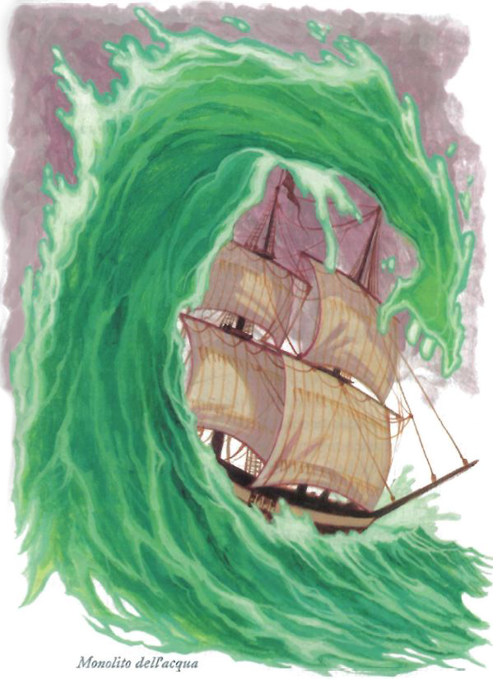MONOLITO DELL’ACQUA

**Elementale Mastodontico (Acqua, Extraplanare)**

**Dadi Vita:** 36d8+327 (490 pf)

**Initiativa:** +6

**Velocità:** 9 m (6 square), nuotare 36 m

**Classe Armatura:** 27 (–4 size, +6 Dex, +15 natural), contatto 12, colto alla sprovvista 21

**Attacco base/Lotta:** +27/+53

**Attacco:** Schianto +45 in mischia (6d8+16/19-20 [40])

**Attacco completo:** 2 schianti +45 in mischia (6d8+16/19-20 [40])

**Spazio/Portata:** 6m/6m

**Attacchi speciali:** Bagnare, vortice, padronanza dell’acqua, Colpo Accurato

**Qualità speciali:** Riduzione del danno 15/-, scurovisione 18m, tratti degli elementali, Resistenza all’acido e all’elettricità 15, Riduzione danno 10/magia, Resistenza agli incantesimi 25, Forma alternativa, Epic summoning

**Tiri salvezza:** Temp +39, Rifl +30, Vol +26

**Caratteristiche:** For 42, Dex 22, Cos 29, Int 12, Sag 15, Car 17

**Abilità:** Ascoltare +43, Diplomazia +5, Intimidire +16, Nuotare +25, Osservare +43, Percepire Intenzioni +15, Saltare +30

**Talenti:** Allerta, Arma focalizzata (schianto), Attacco Naturale Migliorato, Attacco Poderoso, Colpo Terrificante, Critico Migliorato (schianto), Incalzare, Incalzare Potenziato, Riflessi Fulminei, Schivare, Spezzare Migliorato, Spingere Migliorato, Volontà di Ferro

**Ambiente:** Piano Elementale dell’Acqua

**Organizzazione**: Solitario

**Grado Sfida:** 17

Combattimento

**Bagnare (Str):** Il tocco di un monolito dell’acqua spegne torce, fuochi da campo, lanterne esposte e altre fiamme non protette di origine non magica se sono di taglia Enorme o inferiore. La creatura può dissolvere i fuochi magici che tocca, come se usasse *dissolvi magie superiore* (20° livello dell’incantatore).

**Vortice (Str):** Un monolito dell’acqua può trasformarsi in un vortice a volontà come azione standard e può rimanere in quella forma per tutto il tempo che desidera. È largo 3 metri dalla base e si allarga fino a 15 metri in cima, per un’altezza di 24 metri.

In questa forma non provoca attacchi di opportunità. Creature di taglia Enorme o inferiore subiscono danni quando catturate in un vortice e possono essere spazzate via da esso, devono effettuare un TS sui Riflessi con CD 42 quando entrano in contatto con il vortice o subire 4d6 danni ed essere completamente sollevate e tenute sospese dalle forti correnti subendo i danni indicati ogni round. Ogni round alle creature è concesso un TS sui Riflessi per sfuggire al vortice.

Una creatura intrappolata non può muoversi e viene trascinata dal monolito, deve effettuare una prova di Concentrazione (CD 20 + livello dell’incantesimo) per lanciare un incantesimo. Le creature all’interno subiscono una penalità di -4 alla Destrezza e -2 ai tiri per colpire. Un monolito può avere al massimo tante creature intrappolate quante ce ne stanno dentro al volume del vortice, e può rilasciarne un qualsiasi numero ogni round come azione gratuita.

**Padronanza dell’acqua (Str):** Un monolito dell’acqua ottiene un bonus di +2 ai tiri per colpire e per i danni se sia lui che l’avversario sono a contatto con l’acqua, se sia lui che l’avversario stanno toccando il terreno, il monolito subisce una penalità di -4 ai tiri per colpire e per i danni.

**Colpo accurato (Sop):** Una volta al giorno una creatura pseudonaturale può ottenere un bonus cognitivo di +20 ad un singolo tiro per colpire. Inoltre, la creatura non subisce alcuna probabilità di mancare il bersaglio contro un bersaglio che abbia occultamento od occultamento totale quando compie questo attacco.

**Forma alternativa (Sop):** Come azione standard, una creatura pseudonaturale può assumere la forma di una grottesca massa tentacolare (o un’altra forma altrettanto raccapricciante, come determinato dal DM). Nonostante l’aspetto alieno, le capacità della creatura rimangono immutate. Altre creature ricevono una penalità morale di -1 ai tiri per colpire contro una creatura pseudonaturale quando questa è in forma alternativa.

**Epic summoning (Su):** The creature makes all its attacks with a +5 insight bonus and get a +10 insight bonus to all saving throws.

MONOLITO Rashemi DELL’ARIA (orglash)

**Elementale Mastodontico (Aria, Extraplanare)**

**Dadi Vita:** 36d8+360 (520 pf)

**Initiativa:** +15

**Velocità:** Volare 30 m (perfetta) (20 quadretti)

**Classe Armatura:** 33 (–4 size, +11 Dex, +16 naturale), contatto 17, colto alla sprovvista 20

**Attacco base/Lotta:** +27/+50

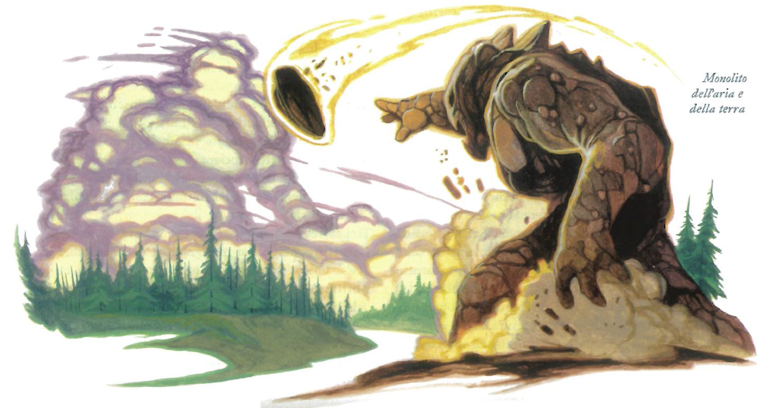**Attacco:** Schianto +40 in mischia (6d6+11/19-20 [30] più 3d6 da freddo [10])

**Attacco completo:** 2 schianti +40 in mischia (6d6+16/19-20 [30] più 3d6 da freddo [10])

**Spazio/Portata:** 6m/6m

**Attacchi speciali:** Turbine, padronanza dell’aria, Cono di freddo, Colpo Accurato

**Qualità speciali:** Riduzione del danno 15/-, scurovisione 18m, tratti degli elementali, Sottotipo freddo, Guarigione rapida fredda Resistenza all’acido e all’elettricità 15, Riduzione danno 10/magia, Resistenza agli incantesimi 25, Forma alternativa, Epic summoning

**Tiri salvezza:** Temp +28, Rifl +41, Vol +26

**Caratteristiche:** For 32, Dex 33, Cos 26, Int 12, Sag 15, Car 17

**Abilità:** Acrobazia +24, Ascoltare +43, Diplomazia +5, Equilibrio +13, Intimidire +16, Osservare +43, Percepire Intenzioni +15, Saltare +41

**Talenti:** Allerta, Arma focalizzata (schianto), Attacco Naturale Migliorato, Attacco Poderoso, Colpo Terrificante, Critico Migliorato (schianto), Incalzare, Incalzare Potenziato, Riflessi Fulminei, Schivare, Mobilità, Schivare, Volontà di Ferro

**Ambiente:** Piano Elementale dell’Aria

**Organizzazione**: Solitario

**Grado Sfida:** 17

Combattimento

**Padronanza dell’aria (Str):** Le creature volanti subiscono una penalità di -2 ai tiri per colpire e per i danni contro un monolito dell’aria.

**Turbine (Sop):** Un monolito dell’aria può trasformarsi in un vortice a volontà come azione standard e può rimanere in quella forma per tutto il tempo che desidera. È largo 3 metri dalla base e si allarga fino a 15 metri in cima, per un’altezza di 24 metri.

In questa forma non provoca attacchi di opportunità. Creature di taglia Enorme o inferiore subiscono danni quando catturate in un vortice e possono essere spazzate via da esso, devono effettuare un TS sui Riflessi con CD 40 quando entrano in contatto con il vortice o subire 4d6 danni ed essere completamente sollevate e tenute sospese dalle forti correnti subendo i danni indicati ogni round. Ogni round alle creature è concesso un TS sui Riflessi per sfuggire al vortice.

Una creatura intrappolata non può muoversi e viene trascinata dal monolito, deve effettuare una prova di Concentrazione (CD 20 + livello dell’incantesimo) per lanciare un incantesimo. Le creature all’interno subiscono una penalità di -4 alla Destrezza e -2 ai tiri per colpire. Un monolito può avere al massimo tante creature intrappolate quante ce ne stanno dentro al volume del vortice, e può rilasciarne un qualsiasi numero ogni round come azione gratuita.

*Cono di freddo (Mag):* 3 volte al giorno un Orglash può lanciare un cono di freddo lanciato come uno stregone di 36° livello (15d6 danni, Tempra dimezza CD 20).

**Sottotipo del freddo (Str):** Un orglash è immune ai danni da freddo. Gli orglash subiscono metà in più dei danni da fuoco, indipendentemente dal fatto che un tiro salvezza venga concesso o se il tiro salvezza riesca o meno.

**Guarigione rapida fredda (Str):** In condizioni di freddo estremo o di tempo atmosferico freddo, un orglash recupera i punti ferita persi al ritmo di 3 per round.

**Colpo accurato (Sop):** Una volta al giorno una creatura pseudonaturale può ottenere un bonus cognitivo di +20 ad un singolo tiro per colpire. Inoltre, la creatura non subisce alcuna probabilità di mancare il bersaglio contro un bersaglio che abbia occultamento od occultamento totale quando compie questo attacco.

**Forma alternativa (Sop):** Come azione standard, una creatura pseudonaturale può assumere la forma di una grottesca massa tentacolare (o un’altra forma altrettanto raccapricciante, come determinato dal DM). Nonostante l’aspetto alieno, le capacità della creatura rimangono immutate. Altre creature ricevono una penalità morale di -1 ai tiri per colpire contro una creatura pseudonaturale quando questa è in forma alternativa.

**Epic summoning (Su):** The creature makes all its attacks with a +5 insight bonus and get a +10 insight bonus to all saving throws.

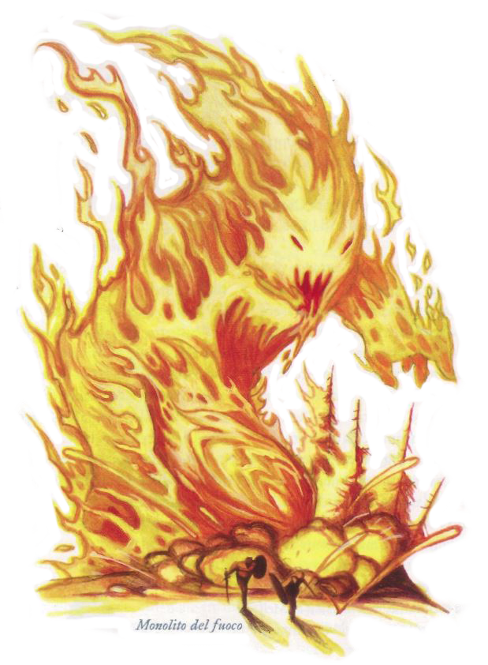

MONOLITO DEL FUOCO

**Elementale Mastodontico (Fuoco, Extraplanare)**

**Dadi Vita:** 36d8+288 (450 pf)

**Initiativa:** +13

**Velocità:** 18 m (12 quadretti)

**Classe Armatura:** 29 (–4 size, +9 Dex, +14 natural), contatto 15, colto alla sprovvista 20

**Attacco base/Lotta:** +27/+50

**Attacco:** Schianto +40 in mischia (6d6+12/19-20 [30] più 4d6 da fuoco [20])

**Attacco completo:** 2 schianti +40 in mischia (6d8+12/19-20 [30] più 4d6 da fuoco [20])

**Spazio/Portata:** 6m/6m

**Attacchi speciali:** Bruciare, Colpo Accurato

**Qualità speciali:** Riduzione del danno 15/-, scurovisione 18m, tratti degli elementali, immunità al fuoco, vulnerabilità al freddo, Resistenza all’acido e all’elettricità 15, Riduzione danno 10/magia, Resistenza agli incantesimi 25, Forma alternativa, Epic summoning

**Tiri salvezza:** Temp +30, Rifl +39, Vol +26

**Caratteristiche:** For 32, Dex 29, Cos 22, Int 12, Sag 15, Car 17

**Abilità:** Acrobazia +24, Ascoltare +43, Diplomazia +5, Equilibrio +13, Intimidire +16, Osservare +43, Percepire Intenzioni +15, Saltare +25

**Talenti:** Allerta, Arma focalizzata (schianto), Attacco Naturale Migliorato, Attacco Poderoso, Colpo Terrificante, Critico Migliorato (schianto), Incalzare, Incalzare Potenziato, Iniziativa migliorata, Schivare, Mobilità, Riflessi in combattimento, Volontà di Ferro

**Ambiente:** Piano Elementale del Fuoco

**Organizzazione**: Solitario

**Grado Sfida:** 17

Combattimento

**Bruciare (Str):** L’attacco di schianto di un monolito del fuoco infligge danni contundenti più danni da fuoco grazie al corpo infuocato della creatura. Chiunque sia colpito dall’attacco di schianto di un monolito del fuoco deve effettuare consuccesso un TS sui Riflessi con CD 34 o prendere fuoco. Le fiamme bruciano per 1d4 round. A meno che non sia ancora a contatto con il monolito del fuoco, una creatura in fiamme può compiere un’azione di movimento per spegnere le fiamme. La CD del tiro salvezza è basata sulla Costituzione.

Le creature che colpiscono un monolito del fuoco con armi naturali o attacchi senz’armi subiscono danni da fuoco come se fossero colpite dall’attacco del monolito, e inoltre prendono fuoco se non superano un tiro salvezza sui Riflessi con CD 34.

**Colpo accurato (Sop):** Una volta al giorno una creatura pseudonaturale può ottenere un bonus cognitivo di +20 ad un singolo tiro per colpire. Inoltre, la creatura non subisce alcuna probabilità di mancare il bersaglio contro un bersaglio che abbia occultamento od occultamento totale quando compie questo attacco.

**Forma alternativa (Sop):** Come azione standard, una creatura pseudonaturale può assumere la forma di una grottesca massa tentacolare (o un’altra forma altrettanto raccapricciante, come determinato dal DM). Nonostante l’aspetto alieno, le capacità della creatura rimangono immutate. Altre creature ricevono una penalità morale di -1 ai tiri per colpire contro una creatura pseudonaturale quando questa è in forma alternativa.

**Epic summoning (Su):** The creature makes all its attacks with a +5 insight bonus and get a +10 insight bonus to all saving throws.

MONOLITO Rashemi DELLA TERRA (thomil)

**Elementale Mastodontico (Terra, Extraplanare)**

**Dadi Vita:** 36d8+419 (580 pf)

**Initiativa:** -2

**Velocità:** 9 m (6 square), nuotare 36 m

**Classe Armatura:** 32 (–4 size, -2 Dex, +28 natural), contatto 4, colto alla sprovvista 25

**Attacco base/Lotta:** +27/+55

**Attacco:** Schianto +45 in mischia (6d8+16/19-20 [40])

**Attacco completo:** 2 schianti +45 in mischia (6d8+16/19-20 [40])

**Spazio/Portata:** 6m/6m

**Attacchi speciali:** Padronanza della terra, spinta, avvolgere Colpo Accurato

**Qualità speciali:** Riduzione del danno 15/-, scurovisione 18m, tratti degli elementali, Macigno difensivo, Scorrere sulla terra, Resistenza all’acido e all’elettricità 15, Resistenza al freddo 10, Riduzione danno 10/magia, Resistenza agli incantesimi 41, Forma alternativa, Epic summoning

**Tiri salvezza:** Temp +37, Rifl +20, Vol +26

**Caratteristiche:** For 43, Dex 6, Cos 28, Int 12, Sag 15, Car 17

**Abilità:** Ascoltare +43, Diplomazia +5, Intimidire +16, Osservare +43, Percepire Intenzioni +15, Saltare +30

**Talenti:** Allerta, Arma focalizzata (schianto), Attacco Naturale Migliorato, Attacco Poderoso, Colpo Terrificante, Critico Migliorato (schianto), Incalzare, Incalzare Potenziato, Oltrepassare Migliorato, Robustezza, Spezzare Migliorato, Spingere Migliorato, Lottare Migliorato, Volontà di Ferro

**Ambiente:** Piano Elementale della Terra

**Grado Sfida:** 17

Combattimento

**Padronanza della terra (Str):** Un monolito della terra ottiene un bonus di +2 ai tiri per colpire e per i danni se sia lui che il nemico sono a contatto con il terreno. Se un avversario sta volando o è in acqua, il monolito subisce una penalità di -4 ai tiri per colpire e ai danni.

**Spinta (Str):** Un monolito della terra può iniziare una spinta senza provocare attacchi di opportunità. I modificatori di combattimento indicati in “padronanza della terra” si applicano anche alle prove di Forza contrapposte del monolito.

**Scorrere sulla terra (Str):** Un monolito della terra può scorrere attraverso pietra, terriccio o qualsiasi altro tipo di terra ad eccezione del metallo con la stessa facilità con cui un pesce nuota nell’acqua. La sua azione di scavare non lascia dietro di sé nessun tunnel o buco, né crea alcuna increspatura o altro segno della sua presenza. Un incantesimo *muovere il terreno* lanciato in un’area contenente un monolito della terra che sta scavando respinge indietro la creatura di 9 metri, stordendola per 1 round a meno che non effettui con successo un tiro salvezza sulla Tempra con CD 15.

**Avvolgere (Str):** Con un’azione standard, un thomil può tentare di avvolgere un avversario che sia di almeno una categoria di taglia inferiore alla sua. Non può effettuare un attacco con schianto nel round in cui avvolge la sua preda. Il Thomil deve semplicemente muoversi sopra i suoi avversari, colpendo tutti quelli che può ricoprire. Gli avversari possono effettuare attacchi di opportunità contro il Thomil, ma se lo fanno non avranno diritto ad un tiro salvezza. Coloro che non effettuano attacco di opportunità devono effettuare con successo un tiro salvezza sui Riflessi (CD 40) o essere avvolti. In caso di successo del tiro salvezza, saranno invece spinti all’indietro o di fianco (a scelta dell’avversario) mentre il Thomil si sposta in avanti.

Le creature avvolte si considerano in lotta e intrappolate all’interno del corpo del Thomil, e subiscono automaticamente 2d8+17 [25] danni da strangolamento ogni round.

Una creatura avvolta può tentare di farsi strada al di fuori del corpo del Thomil con gli artigli oppure con un’arma leggera tagliente o perforante. Infliggere almeno un quarto dei normali punti ferita dell’elementale (CA colto alla sprovvista) in questo modo crea un’apertura grande abbastanza da consentire la fuga. Una volta uscita una singola creatura, il corpo del Thomil si rimodella per chiudere la ferita, quindi un altro avversario ingoiato deve farsi strada da sé. La creatura avvolta può invece tentare una prova di Artista della Fuga (CD 35). Il corpo del Thomil può contenere due creature di una categoria di taglia inferiore rispetto alla sua, oppure quattro di due o più categorie di taglia inferiori alla sua.

Dopo aver avvolto una creatura, il Thomil può muoversi e attaccare normalmente.

**Macigno difensivo (Str):** Un Thomil può mutare la sua forma in quella di un macigno liscio e immobile. In questa forma la riduzione del danno del Thomil aumenta a 20/- e la sua resistenza agli incantesimi aumenta di 10, ma non può muoversi o effettuare attacchi. Assumere questa forma richiede un’azione standard, mentre ritornare alla forma semiumanoide richiede un’azione gratuita.

**Colpo accurato (Sop):** Una volta al giorno una creatura pseudonaturale può ottenere un bonus cognitivo di +20 ad un singolo tiro per colpire. Inoltre, la creatura non subisce alcuna probabilità di mancare il bersaglio contro un bersaglio che abbia occultamento od occultamento totale quando compie questo attacco.

**Forma alternativa (Sop):** Come azione standard, una creatura pseudonaturale può assumere la forma di una grottesca massa tentacolare (o un’altra forma altrettanto raccapricciante, come determinato dal DM). Nonostante l’aspetto alieno, le capacità della creatura rimangono immutate. Altre creature ricevono una penalità morale di -1 ai tiri per colpire contro una creatura pseudonaturale quando questa è in forma alternativa.

**Epic summoning (Su):** The creature makes all its attacks with a +5 insight bonus and get a +10 insight bonus to all saving throws.

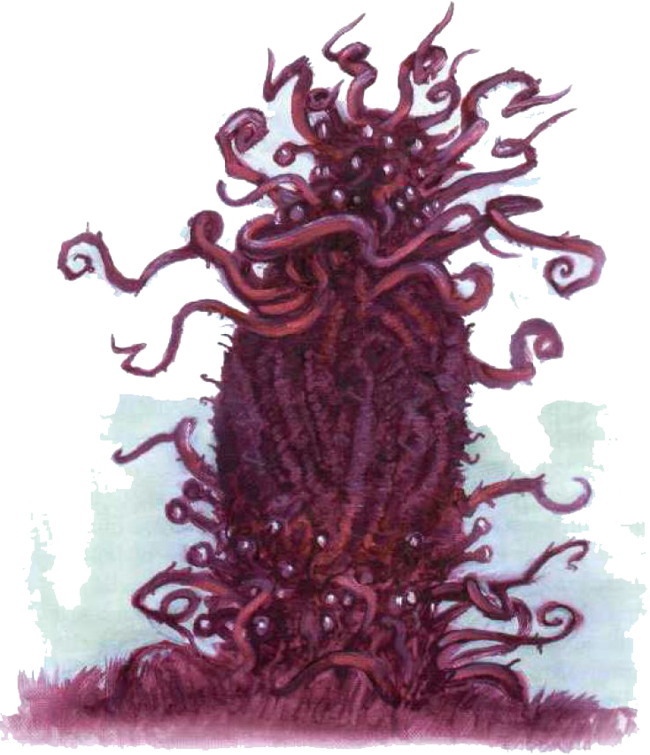Moon-beast  
Pseudonatural

**Aberrazione Enorme**

**Dadi Vita:** 18d8+130 (210 pf)

**Iniziativa:** +2

Velocit**à:** 9 m, scalare 3 m

**CA:** 37 (-2 taglia, +2 Des, +7 naturale, +20 insight), contatto 30, colto alla sprovvista 35

**Attacchi:** 10 speroni da tentacolo +45 in mischia

**Danni:** Sperone da tentacolo 2d6+25 [20]

**Faccia/Portata:** 3 m per 3 m/4,5 m

**Attacchi speciali:** Mordere 4d8+23 [40], stritolare 4d10+28 [50], aura di paura, afferrare migliorato, capacità magiche

**Qualità speciali:** Visione a 360°, scurovisione 18 m, DR 15/magic, spell resistance 25, alternative form, epic summoning, acid resistance 15, electricity resistance 15

**Tiri salvezza:** Temp +33, Rifl +28, Voi +32

**Caratteristiche:** For 34, Des 15, Cos 25, Int 8, Sag 9, Car 18

**Abilità:** Ascoltare +20, Cercare +3, Osservare +18, Scalare +18

**Talenti:** Attacco Poderoso, Riflessi da Combattimento, Volontà di Ferro

**Clima/Terreno:** Qualsiasi terreno e sotterraneo

**Grado di Sfida:** 16

La bestia lunare è un avversario feroce, tenace e decisamente terrificante. Il semplice vederne una può far fuggire forti avventurieri a gambe levate, e il combattere realmente contro una di esse è una sfida ben oltre le capacità di molti, se non degli eroi più potenti. Sfortunatamente, a causa dei legami del mostro con certi congegni magici, alcuni avventurieri si ritrovano inavvertitamente (e spesso fatalmente) coinvolti con una bestia lunare.

Siccome le bestie lunari sono attive solo di notte e di solito sono invisibili, le descrizioni dei testimoni oculari tendono ad essere piuttosto confuse. In realtà, il corpo di una bestia lunare è una massa vagamente cilindrica di carne gelatinosa, di solito alta tra 6 e 9 metri. L'altezza è variabile; anche una singola bestia a volte cambia dimensioni da un'apparizione alla successiva. In una bestia lunare non si riesce distinguere una testa, né un davanti o dietro, né un sopra o sotto: è ugualmente a suo agio con qualsiasi orientamento. Il tronco è circondato ad ogni estremità da un anello di tentacoli. Ogni anello ha un numero di tentacoli pari a 1 + 1/2 dei Dadi Vita della bestia lunare, arrotondati per difetto. (Le bestie lunari avanzate potrebbero avere più tentacoli, e di conseguenza più attacchi con speroni da tentacolo, rispetto alla varietà standard con 18 DV) Questi tentacoli sono ricoperti di ganci e uncini per prendere oggetti o prede, e servono anche come metodi di locomozione per la bestia lunare. Per muoversi, la creatura con i tentacoli afferra oggetti fissati e si trascina in avanti. Il corpo è coperto da una viscida sostanza oleosa. Quattro anelli, ognuno consistente in otto steli oculari flessibili, retrattili e lunghi 30 cm, sono posizionati sopra e sotto ogni anello di tentacoli.

Nonostante le dimensioni immense, una bestia lunare può schiacciare il suo corpo molle per farlo passare attraverso un'apertura piccola quanto un quadrato di 1,5 per 1,5 metri. Dovunque passi, lascia dietro di sé un'evidente scia di fanghiglia luccicante. Le bestie lunari sono invisibili la maggior parte del tempo, ma il loro orribile odore e i rumori che producono quasi costantemente rendono nota la loro presenza a creature buone osservatrici.

COMBATTIMENTO

Una bestia lunare sfrutta la capacità invisibilità migliorata per rimanere invisibile anche in combattimento. In battaglia, una bestia lunare preferisce colpire, afferrare e stritolare. Può usare fino a sette tentacoli contro un singolo bersaglio.

**Mordere (Str):** Con una prova di lotta effettuata con successo, una bestia lunare può tentare di mordere un avversario afferrato (+45 in mischia), infliggendo 4d8+23 [40] danni taglienti per ogni colpo riuscito. Una bestia lunare non può usare il suo attacco col morso contro una creatura che non ha già afferrato.

**Stritolare (Str):** Con una prova di lotta effettuata con successo, una bestia lunare può stritolare un avversario afferrato, infliggendo 4d10+28 [50] danni contundenti.

**Aura di paura (Str):** Una bestia lunare emana in continuazione un effetto di paura in un raggio di 18 metri, centrato su di sé. Qualsiasi creatura all'interno dell'area che fallisce un tiro salvezza sulla Volontà (CD 43) è paralizzata dalla paura per 2d6 round. Un nuovo tiro salvezza è necessario ogni volta che una creatura potenzialmente influenzata giunge nel raggio di azione della bestia lunare.

**Afferrare migliorato (Str):** Se una bestia lunare colpisce un avversario che è almeno una categoria di taglia più piccolo di lei con un attacco con gli speroni da tentacolo, infligge danni normali e tenta di iniziare una lotta come azione gratuita senza provocare un attacco di opportunità (bonus di lotta +51). Se riesce a trattenere, stritola automaticamente e può tentare di mordere l'avversario afferrato nello stesso round. Dopo, la bestia lunare ha l'opzione di svolgere la lotta normalmente o semplicemente usare un singolo tentacolo per trattenere l'avversario (penalità di -20 alla prova di lotta, ma la bestia lunare non è considerata in lotta). In entrambi i casi, per ogni prova di lotta che effettua con successo nei round successivi infligge automaticamente danni da sperone di tentacolo e da stritolamento e permette un altro tentativo di mordere.

**Capacità magiche:** A volontà - dissolvi magie, fulmine, invisibilità migliorata, nube ài nebbia; 1 volta al giorno - catena di fulmini, disintegrazione, evoca mostri VI, immagine speculare, nube mortale, palla di fuoco, tempesta di ghiaccio, tentacoli neri ài Evard. 18° livello dell'incantatore; tiro salvezza CD 14 + livello dell'incantesimo.

**Visione a 360° gradi (Str):** Una bestia lunare può vedere in tutte le direzioni contemporaneamente. Grazie a questa capacità, ottiene un bonus razziale di +4 alle prove di Cercare e Osservare, e non può essere attaccata ai fianchi.

**Epic summoning (Su):** The creature makes all its attacks with a +20 insight bonus to-hit and a 10 insight bonus to damage, gain a +20 insight bonus to all saving throw, a +20 bonus to all CD’s and a +20 insight bonus to CA.

**True strike (Su):** Once per day, a pseudonatural creature can gain a +20 insight bonus on a single attack roll. In addition, the creature suffers no miss chance against a target that has concealment or total concealment when making this attack.

**Alternative form (Su):** As a standard action, a pseudonatural creature can take the form of a grotesque, tentacled mass (or another appropriately gruesome form, as determined by the DM). Despite the alien appearance, its abilities remain unchanged. Other creatures receive a –1 morale penalty on their attack rolls against a pseudonatural creature when it is in this alternate form.

Zeugalak  
Pseudonatural

**Huge Aberration (Extraplanar)**

**Hit Dice:** 16d8+128 (250 hp)

**Initiative:** +3

**Speed:** 30 ft. (6 squares), climb 30 ft.

**Armor Class:** 45 (–2 size, +3 Dex, +14 natural, +20 insight), touch 31, flat-footed 42

**Base Attack/Grapple:** +12/+39

**Attack:** Tentacle +40 melee (1d8+21[25] plus 1d6 electricity/19–20/×3)

**Full Attack:**

3 tentacles +40 melee (1d8+21[25] + 1d6 electricity [3] /19– 20/×3)

+ 2 claws +38 melee (1d8+16[20] plus 1d6 electricity [3])

+ sting +38 melee (1d8+16[20] plus 1d6 electricity [3] plus poison)

**Space/Reach:** 15 ft./10 ft. (30 ft. with sting)

**Special Attacks:** Augmented critical, breath weapon, electrical aura, improved grab, pinning, poison, true strike

**Special Qualities:** Darkvision 60 ft., electrical affinity, electrical teleportation, feather fall, immunity to poison, low-light vision, DR 15/magic, spell resistance 25, alternative form, epic summoning, acid resistance 15, electricity resistance 15

**Saves:** Fort +35, Ref +30, Will +36

**Abilities:** Str 32, Dex 16, Con 30, Int 4, Wis 18, Cha 10

**Skills:** Climb +19, Listen +13, Spot +14

**Feats:** Combat Reflexes, Improved Critical (tentacle), Iron Will, Lightning Reflexes, Multiattack, Run

**Environment:** Warm mountains

**Challenge Rating:** 12

**Alignment:** Usually chaotic neutral

*This creature darts and weaves with shocking agility for something so massive. It has four saurian legs that each end in a single massive talon. An incredibly long, whiplike stinger thrashes atop the beast, and what must be its head 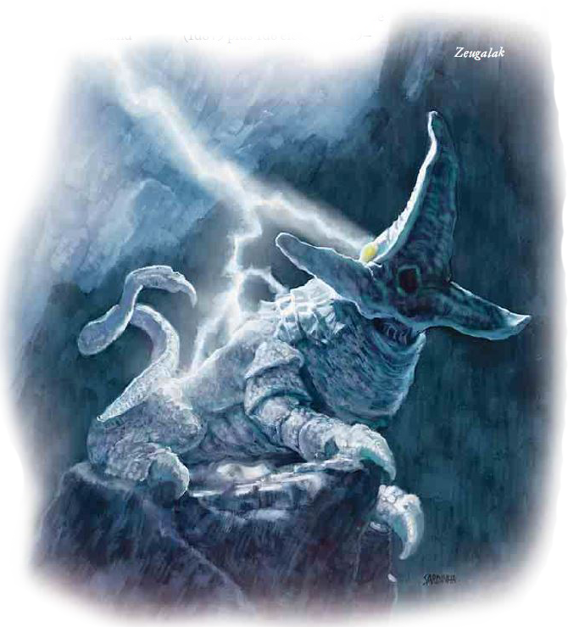consists of three tentacles that peel back to expose inner surfaces covered with hundreds of sharklike teeth and a gaping circular maw. Arcs of electricity dance over the monster’s pale blue and white skin, and three huge yellow eyes glare from above its mouth.*

The dreaded zeugalak is a dangerous predator found on the lower slopes of rugged mountains in tropical regions, although it has been encountered in large underground regions as well. A zeugalak isn’t particularly intelligent, but it is nonetheless a patient and observant monster that defends its chosen territory quite fiercely.

A zeugalak is a nocturnal creature, although sunlight doesn’t impede its sensitive eyesight. Zeugalaks are especially active during thunderstorms and cavort atop mountain peaks during such weather. Their terrible bellows of delight when they are struck by bolts of lightning can carry for miles. When struck, they use their electrical teleportation ability to teleport high into the clouds above so they can enjoy the long feather fall back to the ground below through the surrounding storm.

A zeugalak is about 26 feet long and weighs about 22,000 pounds.

COMBAT

A zeugalak is fond of initiating combat with a charge attack, although it also uses feather fall to drop down on targets from high ledges. Once in melee, the creature splits its attacks among all targets in reach, using its Combat Reflexes and the incredible reach of its stinger to disrupt spellcasters and any attempts to flank it. It uses its breath weapon against those who try to stay out of its melee reach.

**Augmented Critical (Ex):** A zeugalak’s tentacles deal ×3 damage on a successful critical hit.

**Breath Weapon (Su):** 100 ft. line, once every 1d4 rounds, damage 12d6 electricity, Reflex DC 36 half. The save DC is Constitution-based.

**Electrical Aura (Su):** A zeugalak’s body is constantly shrouded in an aura of electrical energy. Any creature that successfully strikes a zeugalak with a melee weapon or natural weapon takes 1d6 points of electricity damage. Each of a zeugalak’s melee attacks deals an extra 1d6 points of electricity damage on a hit. This additional damage is not multiplied on a critical hit.

**Improved Grab (Ex):** To use this ability, the zeugalak must hit a creature that is at least two size categories smaller than it with a claw attack. It can then attempt to start a grapple as a free action without provoking attacks of opportunity. If it wins the grapple, it establishes a hold and can attempt to pin the opponent in the following round.

**Pinning (Ex):** A zeugalak that pins an opponent with a claw deals claw damage (1d8+14 [20]) and twice its normal electricity damage (3d6 [10]) in each round it maintains the pin. While maintaining a pin with its claw, it can continue to attack other targets with its other attacks (and can even pin another target with its other claw).

**Poison (Ex):** Injury (sting), Fortitude DC 36, initial and secondary damage 1d10 [5] Str. The save DC is Constitution-based.

**Electrical Affinity (Su):** A zeugalak takes no damage from electricity. Instead, any electricity attack used against a zeugalak (except for an electricity attack that originates from a zeugalak) temporarily grants it 1d4 [2] points of Dexterity. The zeugalak loses these points at the rate of 1 per hour.

**Electrical Teleportation (Su):** If a zeugalak gains points to its Dexterity from an electricity-based attack, it can instantly teleport (as the spell greater teleport) to the source of the electrical attack. This ability is a free action that does not provoke attacks of opportunity and can be used once per minute. A zeugalak can use this ability even on another creature’s turn.

**Feather Fall (Su):** At will, a zeugalak can use a feather fall effect (as the spell, caster level 16th) with personal range.

**Epic summoning (Su):** The creature makes all its attacks with a +20 insight bonus to-hit and a 10 insight bonus to damage, gain a +20 insight bonus to all saving throw, a +20 bonus to all CD’s and a +20 insight bonus to CA.

**True strike (Su):** Once per day, a pseudonatural creature can gain a +20 insight bonus on a single attack roll. In addition, the creature suffers no miss chance against a target that has concealment or total concealment when making this attack.

**Alternative form (Su):** As a standard action, a pseudonatural creature can take the form of a grotesque, tentacled mass (or another appropriately gruesome form, as determined by the DM). Despite the alien appearance, its abilities remain unchanged. Other creatures receive a –1 morale penalty on their attack rolls against a pseudonatural creature when it is in this alternate form.